Enhancing Employee Innovation and Organizational Agility: Using Transformational Leadership in UAE Smart Government Entities

Khalfan Mohammed Alshamsi  Abu dhabi School of management  adsm-215873@adsm.ac.ae  ORCID: 0009-0002-4415-6085 | Abualla Ali Alketbi  Abu dhabi School of management  adsm-215871@adsm.ac.ae  ORCID: 0009-0004-4228-9719 | Dr. Turki Al Masaeid  Abu dhabi School of management  t.almasaeid@adsm.ac.ae  ORCID: 0000-0002-7901-5656

https://doi.org/10.63962/JWHC3143

ABSTRACT— The study examines how transformational leadership can contribute to the innovation and agility of employees and organizations in UAE smart government institutions. Even though a lot of money has been spent on the digital infrastructure most government departments have not been able to develop innovative organizational cultures that can harness all the technological abilities. Using a quantitative survey that was conducted with 150 government employees that work in three large entities in the UAE, this paper was able to investigate the effects of transformational leadership in enhancing the innovative behaviors of employees and responsiveness of organizations. The results indicate that transformational leadership has a strong influence on the worker innovation (β = 0.68, p < 0.001) and organizational nimbleness (β = 0.72, p < 0.001). The main suggestions are to create the leadership programs based on transformational skills, develop the innovation systems, develop the cross-functional digital teams, and introduce the performance measurements in accordance with the innovation outcomes. The present study would be relevant to the comprehension of leadership-powered digital transformation in the government setting and offer practical suggestions to UAE policymakers that are working on the Digital Government Strategy 2025.
Keywords—Transformational Leadership, Employee Innovation, Organizational Agility

INTRODUCTION
The UAE has placed itself among top world leaders in digital transformation of the government due to the UAE Digital Government Strategy 2025. The overall framework is new to bring about full digitization of the government services with the focus being to reach 90% federal services completed end to end digitally. The plan focuses on digital by design, data-centric strategies, being proactive and delivering services to people in a user-centric manner with a goal of training 10,000 federal government workforces on the use of artificial intelligence, blockchain and Internet of Things technologies.
Nevertheless, even with the significant investment in technology a significant disparity exists between the digital infrastructure

implementation and the innovation capabilities of organizations. The challenge is that many of the UAE government departments have sophisticated digital resources but cannot create an organizational culture that is creative enough to utilize them to the fullest. It is no longer a technological infrastructure that is needed in the digital transformation process but leadership strategies that ensure

employees are creative, take calculated risks, and respond to changing needs of citizens quickly.
The UAE smart government organizations are in a paradox situation wherein massive digital infrastructure investments have not been proportionately transferred to the creation of innovative organizational behaviors and responsive operations. Digital technologies are usually implemented by government departments in a reactive manner when a particular tool is used to replicate an already-existing process instead of entirely reinventing the service delivery paradigm. Workers can have access to a sophisticated system without the psychological safety, motivation, and leadership that support experimenting with new ways of doing things respectively trying out old ones.
Moreover, organizational agility the ability to feel environmental shifts and react quickly by reconfiguring resources and processes has not been well developed in most government organizations. The nature of traditional public sector such as risk aversion, rigidity of procedures and hierarchical decision-making systems prevents the ability to take flexible and adaptive behaviors that are imperative in governance in digital age.
The proposed research is expected to investigate the application of the transformational leadership concept in improving employee innovation and organizational agility in smart government organizations in the UAE. The purpose of the specific objectives is to: (1) understand the exercise of current transformational leadership practices and scope of gaps impeding innovation; (2) assess the relationship between transformational leadership actions and employee behaviors indicating innovative work to the organization; (3) determine the influence of transformational leadership on organizational agility; (4) identify the mediator variables e.g. organizational culture which has been facilitating or restricting the effects of transformational leaders; as well as (5) develop actionable recommendations to government leaders and policymakers.

LITERATURE REVIEW

Transformational Leadership Theory
Transformational leadership: Transformational leadership was developed by Bass and Avolio as a paradigm in which leaders inspire followers to be more motivated, morally uplifted, and working more effectively by their ability to articulate a vision and through inspirational communications and providing a good example. The model considers four dimensions which include the idealized influence (role modelling), inspirational motivation (communication of strong visions), intellectual stimulation (fostering creativity and challenging assumptions), and an individualized consideration (attention to development needs) dimension. Studies prove that the ability of transformational leadership to create innovation-fearing conditions through the development of psychological safety allows employees to suggest innovative ideas without the fear of being penalized (Afsar and Umrani, 2020).

Employee Innovation in Digital Transformation
The innovative behavior of employees includes identifying the problem, developing innovative ideas, promoting, and putting new ideas to practice. In digital transformation situations, innovation means not just technology adoption, but process redesigning, service model innovation and cooperation with a focus on harnessing the digital potential. The studies conducted in the framework of the UAE public sector confirm that HRM practices, innovation climate, and the productivity of the employees proved to be highly interrelated (AlDhaheri et al., 2023). Research indicated that difficult appraisal-framing digital transformation as an opportunity and not a threat and organizational culture support play a very important role as critical mediators between digital transformation initiatives and innovative behaviors of employees.

Organizational Agility and Digital Transformation
Organizational agility is the ability to perceive the changes in the environment, make fast decisions and respond to changes by reconfiguring resources and adapting processes. It has been shown that organizational agility is a mediator variable that plays a critical role in linking digital transformational leadership and desirable results of digital transformation (AlNuaimi et al., 2022). Research based on structural equation modeling shows that digital transformational leadership is a significant contributor of organizational agility that contribute to digital transformation success. This relationship under mediation suggests that leadership will have effects on digital transformation results in the form of creating organizational abilities to adapt quickly, as opposed to technological intervention.

UAE Smart Government Context
The Digital Government Strategy 2025 of the UAE lays up an elaborate set of structures which include digital enablers such as unified digital identity schemes, national digital wallets, and national online signature. Nevertheless, studies that analyze the topic of UAE government digital transformation indicate that certain challenges are still present. In the research conducted by Al Qudah (2024) on 223 government employees, digital transformation adoption has challenges that have to be overcome with prudent leadership methods that focus on the quality of decisions, the effectiveness of communication, and ethical issues. The research examining the smart government effectiveness in the UAE public organizations illustrates that internal government efficiency and infrastructure to implement the smart government services are significant predictors of smart government success (Abdulqader and Al Marri, 2020). Based on the existing literature, this paper presents a theoretical framework that examines the connections between transformational leadership, employee innovation, and organizational agility in smart government organizations in the UAE. Transformational leadership should enhance innovation among the employees through intellectual stimulation and psychological empowerment. Moreover, it is bound to have a direct influence on the level of organizational agility as it facilitates quicker decision-making and responsive actions. Organizational agility is also expected to improve through employee innovation that would facilitate the execution of emerging ideas and responsive practices. Based on that, the current study develop its hypothesis and conceptual model:
H1: Transformational leadership has a positive impact on innovation by employees.
H 2: Transformational leadership has positive effects on organizational agility.
H3: Organizational agility is positively affected by employee innovation.
Figure 1: conceptual model
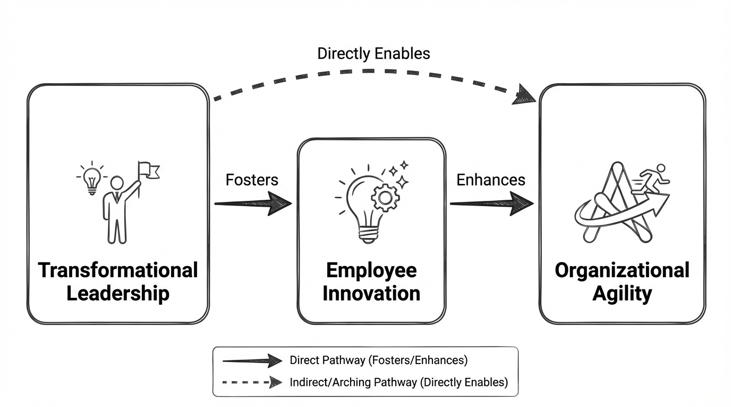

DATA METHODOLOGY

Research Design
Using a quantitative approach, the proposed research involves the use of a structured questionnaire survey as a study instrument to identify correlation between transformational leadership, employee innovation, and organizational agility. The cross-sectional survey design will allow the systematic measurement of leadership behaviors, the perceptions of employees and organizational outcomes as well as the statistical analysis of relationships strength and pattern.

Sample and Data Collection
The target market will include employees of the federal and emirate government agencies located in the UAE who are currently involved in smart government programs. A purposive sampling method was used to identify government organizations that have prepared digital transformation programs. The sample contained workers in three large state organizations who were representing various functional areas. One hundred and fifty complete responses were received in online surveys distribution in a four week time period, a response rate of 62 percent.

Measurement Instruments
Transformational leadership was assessed with the help of the modified Multifactor Leadership Questionnaire which was based on four dimensions. The innovative behavior of employees was evaluated using items assessing the idea generation behavior, promotion behavior, and implementation behaviors that concerned the nature of digital transformations. The measurement of organizational agility was made through the items that evaluated the sensing abilities, speed, and flexibility of decisions, and implementation. The scoring scales were all Likert five-point scales. The demographic questions included in the questionnaire gathered information on age, sex, education, tenure in the organization and level of position.

Data Analysis
Data screening, followed by calculating descriptive statistics, reliability, and correlation analyses were performed to examine bivariate relationships and determine primary hypotheses of the research taking into account the demographics. Further discussion involved possible mediating variables through which transformational leadership can have an influence.

Measurement Model Assessment

The constructs were tested with the help of Confirmatory Factor Analysis (CFA) to determine the validity and reliability of the measures. Measurement model was found to have acceptable fit indices, with the indices being greater than recommended values (CFI > 0.90, TLI > 0.90, RMSEA < 0.08, SRMR < 0.08).

Convergent validity was achieved since all the loading factors were significant and greater than 0.60. Also, the all constructs values of AVE were greater than 0.50 and the values of Composite Reliability (CR) were greater than 0.70; these values were satisfactory internal consistency values.

Ethical Considerations and Limitations
The study was conducted according to ethical principles such as informed consent, protection of confidentiality and voluntary participation. Permission to conduct the surveys was received by the organizations in advance. Limitations involve that cross-sectional design did not allow attributing definite causality, the possible risk of self-report bias due to the use of self-report questions, purposive sampling, and possible generalizability as it was narrow to UAE contexts, and the possibility that there was a limit in the scope of transferability to other contexts due to the cultural circumstances of the UAE. Due to the self-reported information, a single factor test of Harman was performed to determine whether common method bias was present. These findings were that there is no one factor that explained the most variance (less than 50%), which means that the common method bias is not a major issue in this research.

FINDINGS, ANALYSIS, AND DISCUSSION

Sample Characteristics
The population sample so formed was 150 government employees containing 58 and 42 per cent males and females respectively. The age range was 23% at the age of 25-30, 31% in the age range of 31-35 years, 28% in the 36-40 years age range, and 18% above 40 years. The level of education was found to be highly qualified with 67% having bachelor degrees, 28% with master degrees while 5% had doctoral qualifications. The position levels were 41 percent frontline, 43 percent supervisory staff as well as 16 percent middle management.

Descriptive Statistics and Reliability
Transformational leadership had a mean rating of 3.62 (SD = 0.74) on the five-point scale, employee innovative behavior had a mean of 3.48 (SD = 0.68), and organizational agility had a mean of 3.71 (SD = 0.62). Internal consistency was found to be acceptable according to the reliability analysis: the transformational leadership had a Cronbach alpha of 0.89, employee innovative behavior of 0.86 and organizational agility of 0.88.

Table 1: Descriptive Statistics and Reliability Coefficients
Variable | Mean | SD | Cronbach α
Transformational Leadership | 3.62 | 0.74 | 0.89
Employee Innovative Behavior | 3.48 | 0.68 | 0.86
Organizational Agility | 3.71 | 0.62 | 0.88

Correlation Analysis
The Pearson correlation analysis showed that there were significant positive correlations between the primary study variables. Transformational leadership showed a good positive relationship with employee innovative behavior (r = 0.65, p < 0.001) and organizational agility (r = 0.69, p < 0.001). Innovative behavior among the employees and agility of an organization were highly correlated (r = 0.58, p < 0.001). Looking at transformational leadership dimensions in isolation, intellectual stimulation was found to be having the highest correlations with both the innovative behavior (r = 0.71, p < 0.001) and the organizational agility (r = 0.68, p < 0.001).
Table 3: Correlation Matrix (*** p < 0.001)
Variable | TL | EIB | OA
Transformational Leadership (TL) | 1.00 | - | -
Employee Innovative Behavior (EIB) | 0.65*** | 1.00 | -
Organizational Agility (OA) | 0.69*** | 0.58*** | 1.00

Regression Analysis
Various regression analysis on the effect of transformational leadership on employee innovative behavior was statistically significant (F = 45.23, p < 0.001) with a variance explained amounting to 48 (R² = 0.48). The strongest predictor (β = 0.68, t = 9.34, p < 0.001) was the transformational leadership. Education level is the only demographic control that had a significant relationship with innovative behavior (β= 0.18, p < 0.05). Additional result showed that when all the dimensions were simultaneously tested, intellectual stimulation (β = 0.52, p < 0.001) and individualized consideration (β = 0.31, p < 0.01) were significant to predict innovative behavior.
Table 3: Regression Analysis Results (*** p < 0.001, * p < 0.05, ns = not significant)
Predictor | Employee Innovation β | Organizational Agility β
Transformational Leadership | 0.68*** | 0.72***
Education Level | 0.18* | 0.12 ns
R² | 0.48 | 0.53

Regression analysis of the organizational agility was statistically significant (F = 52.18, p = 0.001) and explained 53 percent of variance (R² = 0.53). Transformational leadership was found to be a strong predictor of agility in organizations (β = 0.72, t = 10.67, p < 0.001). The impact of demographic variables on organizational agility perceptions was low. Idealized influence (b = 0.38, p under 0.01) and the intellectual stimulation (β = 0.45, p under 0.001) were the strongest predictors in simultaneous regression.
Figure 1: Transformational Leadership and Employee Innovative Behavior
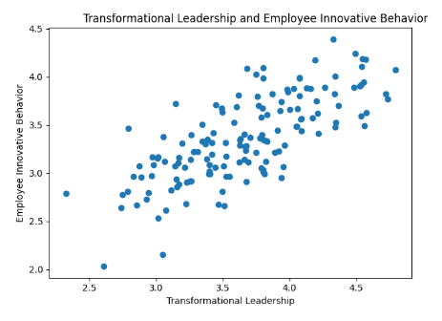
Figure 2: Transformational Leadership and Organizational Agility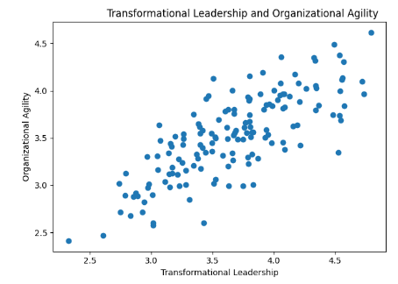

Key Survey Findings
Survey responses provided additional nuanced insights. Most of the respondents (68 percent) were of the opinion that their leaders do push them to look beyond the old frameworks, but only half of the respondents thought that their leaders actively solicit their ideas on how to do services better. To measure innovative behaviors, 71 percent of the respondents claimed to be frequently able to find willingness to enhance service delivery with digital tools, however, 43 percent commonly use innovative ideas. This is an implementation gap that focuses on an obstacle between the responsiveness of the idea and its execution. Also, a third of them were worried of the negative implications of failed innovation efforts indicating that risk aversion is still a major innovation barring factor.
Mixed perceptions were found with organizational agility items. Whereas 67% considered that their organizations are responsive when it comes to responding to the feedback of the citizens, 49% of the respondents felt that their organizations were quick to embrace emerging new technologies whenever they came across such opportunities. In addition, half expressed that bureaucracy is an issue that slows down implementation and forty two percent believed the process of decision making was too centralized.

DISCUSSION
The results offer solid empirical evidence in support of the transformational leadership importance in promoting employee innovation and organizational agility in entities of smart government in the UAE. The positive close relationships that were observed are consistent with theoretical propositions and complement the body of current knowledge as they indicate that these relationships are relevant in the context of digital transformation in the public sector of UAE. The fact that intellectual stimulation has such a potent effect on all the outcomes deserves a mention, and the focus on preventing simplistic assumptions that is inherent in this dimension seems particularly appropriate in the context of digital transformation that demands reconsidering the core processes.
The lag between idea generation and implementation points to a serious issue that needs particular consideration. Whereas transformational leaders are effective in generating creative thinking, structural and systemic obstacles hinder the translation of ideas into solution implemented. It implies that wholesome digital transformation should be taken up concurrently whereby leadership development, organizational structure redesign, resource allocation schemes, and performance evaluation systems that reward innovation efforts irrespective of the short-term results are concerned. Besides the identified direct relationships, the findings support the theoretical assumption that leadership behaviors are central to supporting innovation-driven agility. Transformational leadership, especially via intellectual stimulation, seems to establish a climate of experimentation and adaptability of thought. This is particularly important in the field of digital government, where technology evolves quickly, necessitating constant learning and responsiveness.

RECOMMENDATIONS

Leadership Development Initiatives
The UAE government agencies would need to institute rigorous transformational leadership development initiatives focused on the leadership of all organizational levels in terms of intellectual stimulation and personalized consideration skills. The training modules can incorporate real-life activities of getting to challenge assumptions, conducting creative problem-solving workshops, and offer individual coaching. The introduction of digital transformation-specific content on the issues of application of the transformational behaviors in the environment of the fast change of technology should be introduced into the leadership development. Having mentoring programs in which experienced transformational leaders are paired with the emerging leaders can be used to transfer skills practically.

Innovation Infrastructure and Support Systems
To overcome the implementation gap, the state actors are supposed to have formal innovation infrastructure that helps in idea pushing through idea conception stages to implementation. This infrastructure must have specific innovation teams that review employee proposals, rapid prototyping capabilities that can be used to run tests quickly, and simplified processes that can help facilitate innovation pilot. The mechanisms used to allocate resources should be rigorous in the integration of innovation support, whereby resources available to employees in terms of time, funding and technical support are known. Success and failure Performance appraisal systems need to be reformulated to reward any innovation efforts which should be explicit that not all innovations would be successful.

Organizational Structure and Process Redesign
Government agencies need to establish and remove procedural processes that are now redundant in digital operation space in terms of critical control and accountability roles. Decisions relating to the company also ought to be delegated to the relevant levels such that frontline employees and the supervisors make swift decisions without having a long approval chain. The digital transformation teams that cross-functional team comprised of employees representing various departments would increase the levels of agility and innovation through knowledge sharing and silos reduction as well as ensuring a quicker response to mobilize the capabilities that existed across organizational boundaries.

Culture Change and Performance Metrics
The root cause of continuing risk aversion must be tackled through culturally planned efforts to stress that risk-taking based on calculations and experience-based learning are important elements that should be appreciated. Top management members must repeatedly convey the idea that innovation is a risk and that companies know what to do when the initiative fails. Government agencies are advised to put in place elaborate measures that monitor the innovation efforts, performance agility and transformational leadership practice. Continuous review and reporting of such metrics to the top management keeps the priorities of innovation and nimbleness on the strategic agenda with other conventional performance and compliance indexes.
According to the empirical data, a number of specific recommendations can be suggested:
First, due to the high positive relationship between transformational leadership and employee innovation (b = 0.68), leadership development interventions in government organizations in the UAE should focus on the intellectual stimulation and individualized consideration competencies. These dimensions proved to be the most predictive and are important in encouraging innovative behaviors amongst the employees.
Second, given that the concept of transformational leadership and that of organizational agility are strongly interrelated (b = 0.72), the organizations are supposed to make institutional leadership practices that favor decentralized decision-making and flexible governance systems. This will increase responsiveness and decrease delays of bureaucracies.
Third, the fact that employee innovation and organizational agility have a positive relationship (r = 0.58) demonstrates the necessity to reinforce the innovation implementation mechanisms. The governmental organizations are to introduce the systematic pipelines of innovation (i.e., idea screening, rapid prototyping, cross-functional collaboration platforms).
Lastly, to bridge the perceived gap between the idea generation and implementation, the performance management systems are to be restructured to incentivize the innovation efforts, even failed efforts to prevent risk aversion and promote constant experimentations.
- CONCLUSION
Empirical data on transformational leadership revealed in this research indicates that such leadership is of paramount importance in promoting innovation and agility of employees in smart government organizations in the UAE. Even though the investment in digital infrastructure is significant, to achieve all the potential of transformation it is important to find leadership styles that are particularly used in developing new behaviors of employees and responsiveness of organizations. Intellectual stimulation and one-on-one consideration dimensions of transformational leadership are influential in forecasting employee innovative working behaviors and perceptions of agility in an organization among employees working within the UAE government.
Results show that although UAE government agencies have realized some advancement in digital transformation, there are a series of challenges such as risk aversion, implementation barriers, and structural constriction of agility that still restrain the realization of innovations. The following issues should be systematically addressed by means of leadership development efforts, establishment of an innovation infrastructure, the redesign of the organization, culture change efforts, and the proper performance measurement. Effective digital change does not merely consist of the deployment of technology but poses inherent requirements of the human and organizational capacity development.
The process of full achievement of smart government in the UAE will be defined not only by the level of technological development but also leadership, organizational flexibility, and innovation potential of employees. Transformational leadership is an established method of driving the human and cultural change required to support digital initiatives to reach their scalp in improving citizen services, efficiency in operations, and competitive advantage on the national level. Transformational leadership development should be among the key strategic investments by the government leaders and policymakers in the exploration of agile returns in the long term in the form of innovation, agility, and eventually, the fulfilment of digital government visions.
This research paper will add value to the body of existing literature by empirically confirming the connections between transformational leadership, employee innovation, and organizational agility in the framework of UAE smart government organizations. It builds on the previous studies by illustrating that the influence of behavioral aspects of leadership is fundamental in the transformation of digital infrastructure investments into concrete innovation and agility results.
This study has a number of limitations despite its contribution. The cross-sectional design does not allow causal inference, and future research should consider longitudinal approaches which provide a better capture of dynamic relationship in the course of time. Also, it is recommended that future researchers should use structural equation modeling to better test mediation effects and increase the rigor of analysis.

REFERENCES

- Afsar, B., & Umrani, W. A. (2020). Transformational leadership and innovative work behavior: The role of motivation to learn, task complexity and innovation climate. European Journal of Innovation Management, 23(3), 402-428. https://doi.org/10.1108/EJIM-12-2018-0257
- AlDhaheri, H., Hilmi, M. F., Abudaqa, A., Alzahmi, R. A., & Ahmed, G. (2023). The relationship between HRM practices, innovation, and employee productivity in UAE public sector: A structural equation modelling approach. International Journal of Process Management and Benchmarking, 13(2), 157-178. https://doi.org/10.1504/IJPMB.2023.128471
- AlNuaimi, B. K., Singh, S. K., Ren, S., Budhwar, P., & Vorobyev, D. (2022). Mastering digital transformation: The nexus between leadership, agility, and digital strategy. Journal of Business Research, 145, 636-648. https://doi.org/10.1016/j.jbusres.2022.03.038
- Al Qudah, M. (2024). Digital transformation and wise leadership: Challenges and opportunities evidence from government institutions in UAE. Journal of Police and Legal Sciences, 15(2), Article 5. https://doi.org/10.69672/3007-3529.1026
- Abdulqader, A., & Al Marri, K. (2020). The influence of transformational leadership style on innovation behaviours: The case of the government sector of the UAE. In A. Abu-Tair, A. Lahrech, K. Al Marri, & B. Abu-Hijleh (Eds.), Proceedings of the II International Triple Helix Summit (pp. 3-16). Springer. https://doi.org/10.1007/978-3-030-23898-8_1
- Alakaş, E. Ö. (2024). Digital transformational leadership and organizational agility in digital transformation: Structural equation modelling of the moderating effects of digital culture and digital strategy. International Journal of Information Management Data Insights, 4(2), Article 100269. https://doi.org/10.1016/j.jjimei.2024.100269
- Ly, B. (2024). The interplay of digital transformational leadership, organizational agility, and digital transformation. Journal of the Knowledge Economy, 15(1), 985-1015. https://doi.org/10.1007/s13132-023-01377-8
- Mergel, I., Ganapati, S., & Whitford, A. B. (2021). Agile: A new way of governing. Public Administration Review, 81(1), 161-165. https://doi.org/10.1111/puar.13202
- Muduli, A., & Choudhury, A. (2024). Exploring the role of workforce agility on digital transformation: A systematic literature review. Benchmarking: An International Journal, 31(4), 1285-1310. https://doi.org/10.1108/BIJ-03-2023-0156
- Shehadeh, M., Almohtaseb, A., Aldehayyat, J., & Abu-AlSondos, I. A. (2023). Digital transformation and competitive advantage in the service sector: A moderated-mediation model. Sustainability, 15(3), 2077. https://doi.org/10.3390/su15032077
- Trischler, J., & Westman, T. J. (2021). Design for experience: A public service design approach in the age of digitalization. Public Management Review, 24(8), 1251-1270. https://doi.org/10.1080/14719037.2021.1899272
- United Arab Emirates Government. (2024). UAE Digital Government Strategy 2025. Retrieved from https://u.ae/en/about-the-uae/strategies-initiatives-and-awards/strategies-plans-and-visions/government-services-and-digital-transformation/uae-national-digital-government-strategy
- Weber, E., Büttgen, M., & Bartsch, S. (2022). How to take employees on the digital transformation journey: An experimental study on complementary leadership behaviors in managing organizational change. Journal of Business Research, 143, 225-238. https://doi.org/10.1016/j.jbusres.2022.01.036
- Zafar, H., Ko, M. S., & Osman, I. H. (2024). Navigating digital transformation in the UAE: Benefits, challenges, and future directions in the public sector. Information, 13(11), 281. https://doi.org/10.3390/info13110281
- Zhang, M., Chen, X., Xie, H., Esposito, L., Parziale, A., Taneja, S., & Siraj, A. (2024). Top of tide: Nexus between organization agility, digital capability and top management support in SME digital transformation. Heliyon, 10(10), e31579. https://doi.org/10.1016/j.heliyon.2024.e31579

