Unveiling Latent Burnout Profiles: An Unsupervised Machine Learning Analysis of Global Teacher Data

Fatmah Frishan Alkhzaimi
Department of Graduate Programs & Research
Rochester Institute of Technology
Dubai, United Arab Emirates
ffa4620@g.rit.edu

Dr. Ayman Ibrahim
Associate Professor
Department of Graduate Programs & Research
Rochester Institute of Technology
Dubai, United Arab Emirates
ayman.ibrahim@rit.edu
https://doi.org/10.63962/AWWL3648

Abstract—Teacher burnout is a persistent global challenge with significant consequences for educator wellbeing, instructional quality, and educational system stability. Traditional assessment approaches rely on predefined scales with fixed cut-off scores, which often fail to capture how burnout structurally manifests across diverse cultural and institutional contexts. This study proposes a data-driven, unsupervised machine learning framework to identify latent burnout-related patterns using the OECD TALIS 2018 dataset. K-Means clustering is applied to multidimensional proxy indicators of stress, workload, and wellbeing across 11 education systems, resulting in two distinct latent profiles representing higher-risk and lower-risk burnout-related patterns. As TALIS does not directly measure clinical burnout, these profiles reflect inferred risk patterns derived from proxy indicators rather than diagnostic measures. The findings demonstrate that unsupervised learning can uncover meaningful structural patterns in teacher wellbeing, providing a foundation for scalable predictive modeling and early identification of burnout-related risk.
Keywords—Teacher Burnout, Unsupervised Learning, K-Means Clustering, TALIS 2018, Educational Data Mining.

Introduction
Teacher burnout has evolved from a specialized occupational hazard into a global challenge affecting educator wellbeing and the stability of educational systems. Characterized by emotional exhaustion, depersonalization, and reduced professional accomplishment, burnout is associated with lower instructional quality, decreased student engagement, and higher attrition rates [1], [2].Despite extensive research, the literature largely remains descriptive, with limited focus on how burnout develops structurally across diverse, cross-cultural contexts. A key limitation is the reliance on predefined survey constructs, which assume uniform manifestation and classify burnout using fixed thresholds. While machine learning (ML) enables the modeling of complex, nonlinear relationships [10], many existing approaches still depend on predefined burnout labels, limiting their ability to capture natural variation in teacher wellbeing [11].
The study is guided by the following research question:
Can unsupervised machine learning identify latent burnout-related profiles among teachers using proxy indicators derived from large-scale, cross-cultural data?
This research uses the OECD TALIS 2018 dataset, comprising 38,081 teachers across 11 education systems. In the absence of a direct burnout measure, proxy indicators, including workload stress, well-being, and job satisfaction, are used to infer burnout-related patterns. The main contribution of this study is the application of unsupervised learning to large-scale international data to identify latent burnout profiles without predefined labels, offering a scalable and more flexible approach to understanding teacher burnout.

RELATED WORK
Teacher burnout is a multidimensional phenomenon shaped by both psychological and institutional factors. Empirical evidence shows that low self-efficacy and poor wellbeing significantly increase emotional exhaustion, a core burnout component [5], while large scale reviews link burnout to measurable physical health outcomes across 5,000+ teachers in 11 countries [6]. At the institutional level, workload intensity and organizational support are consistently identified as dominant predictors, with structural equation models confirming their strong effect on teacher wellbeing [7]. Burnout also exhibits systemic characteristics; network-based studies show stress can propagate across teaching environments, reinforcing collective risk rather than isolated individual effects [8][9].
Despite strong identification of predictors, most studies rely on localized samples or predefined burnout constructs, limiting generalizability. For example, cross-regional analyses report significant variation in burnout prevalence and predictors across education systems [11], yet models often assume uniform burnout structures. Machine learning approaches have improved predictive performance by capturing nonlinear relationships between stress, workload, and wellbeing variables [3][10]. However, these models are predominantly supervised and depend on predefined burnout labels, introducing structural bias and limiting their ability to detect naturally occurring patterns. Unsupervised methods address this limitation by identifying latent structures directly from the data. Latent Profile Analysis has demonstrated that burnout consists of multiple configurations, with studies identifying up to six distinct profiles and dynamic transitions over time [4]. However, most clustering applications remain limited in scale or context-specific. Therefore, a critical gap exists in applying unsupervised learning to large-scale, cross-cultural datasets. This study addresses this gap by using K-Means clustering on TALIS 2018 data (n = 38,081 teachers) to identify latent burnout-related profiles without relying on predefined labels.

METHODOLOGY
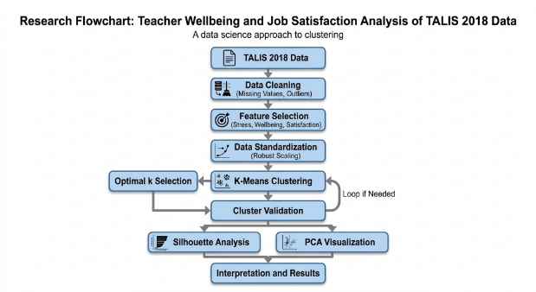
Figure 1: Methodology flowchart

Data Source and Sample Size
This study utilizes data from the OECD Teaching and Learning International Survey (TALIS) 2018, which provides standardized, internationally comparable evidence on teachers' working conditions and wellbeing [12]. A focused subset of 38,081 teachers was extracted. To ensure robust cross-cultural representation and institutional diversity, data was drawn from 11 distinct education systems: Brazil, Chinese Taipei, Croatia, Denmark, Portugal, Viet Nam, Slovenia, Sweden, the United Arab Emirates, Turkey, and Alberta (Canada).

Variable Selection
Variables were selected based on validated OECD composite indicators related to burnout constructs. Because TALIS 2018 does not contain a specific variable explicitly labeled "clinical burnout," the latent profiles were inferred using the following multidimensional indicators:
• Workload Stress (T3WLOAD): Perceptions of stress related to administrative and instructional loads.
• Workplace Wellbeing (T3WELS): Broad occupational strain and health impacts.
• Student Behavior Stress (T3STBEH): Stress arising from classroom management and discipline.
• Job Satisfaction (T3JSENV & T3SATAT): Satisfaction with the work environment and perceived autonomy.

Data Preparation and Preprocessing
To prepare the dataset for algorithmic processing, rigorous data cleaning was conducted. An initial missingness audit revealed incomplete responses across a subset of variables. Because the TALIS items are predominantly categorical or Likert-scaled, mode imputation was applied. This approach successfully resolved missing values (0% missingness post-initial cleaning) without introducing artificial numerical values that would distort discrete response categories. Outlier detection was performed using the Tukey interquartile range (IQR) for continuous workload variables. Extreme values were winsorized at the 1st and 99th percentiles to prevent skewed distributions from disproportionately influencing the clustering algorithms. Finally, because the composite indicators utilized different measurement scales, all selected variables were standardized using Robust Scaling, centering on the median and scaling by the Median Absolute Deviation (MAD). This step is critical for K-Means clustering, ensuring variables with larger numeric ranges do not dominate Euclidean distance calculations.

Unsupervised Learning Framework
K-Means clustering, a distance-based unsupervised learning algorithm, was applied to partition the dataset using standardized indicators of workload stress, workplace wellbeing, and job satisfaction. The algorithm assigns observations to clusters by minimizing the Within-Cluster Sum of Squares (WCSS), thereby improving within-cluster similarity. The optimal number of clusters (k) was determined using the Elbow Method, which evaluates the rate of decrease in WCSS across candidate solutions. Cluster validity was further assessed using Silhouette Analysis, which measures cohesion and separation between clusters. In addition, Principal Component Analysis (PCA) was used as a dimensionality reduction technique to project the data into a two-dimensional space, enabling visual assessment of cluster structure without influencing the clustering outcome.

RESULTS AND DISCUSSION

Determining the Optimal Number of Clusters
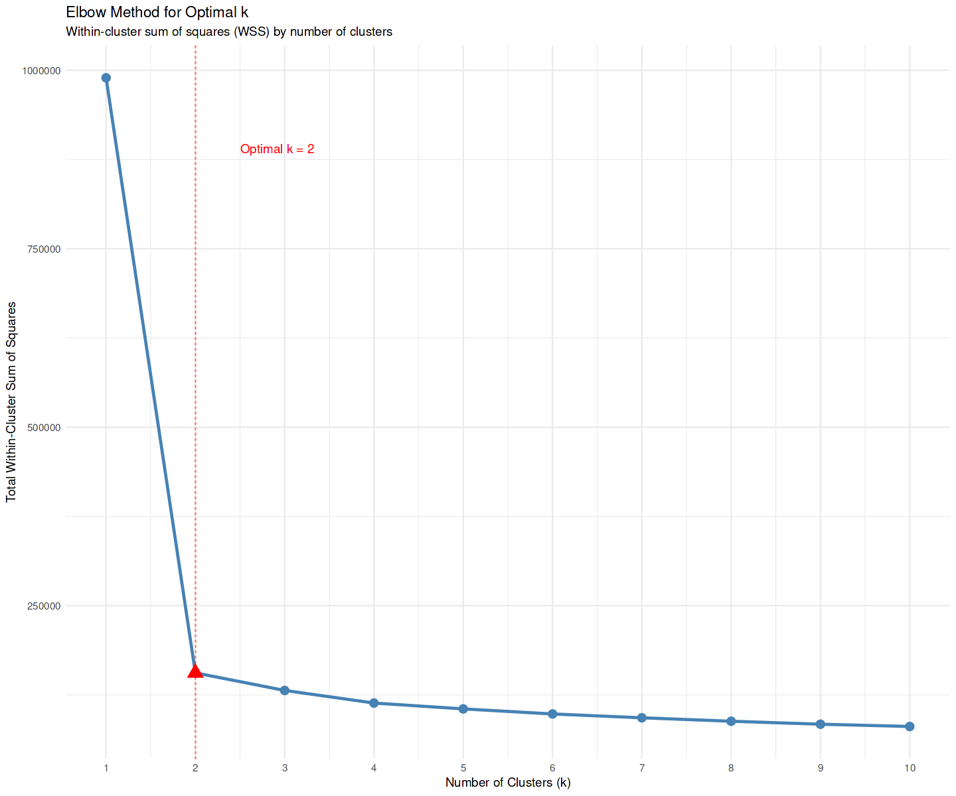
Figure 2: Elbow method for optimal k
The Elbow Method was applied to evaluate candidate cluster solutions ranging from k=1 to k=10. The resulting WCSS curve displayed a sharp, distinct inflection point at k=2, where the steep decline leveled into a significantly flatter trajectory. Specifically, the WCSS dropped from 989,507 at k=1 to 155,840 at k=2, with only marginal improvements beyond this point (e.g., k=3: 108,420), as shown in Figure 2. This suggests that the underlying structure is best represented by two latent burnout-related profiles inferred from proxy indicators, offering diminishing returns and unnecessary fragmentation for higher values of k.

Cluster Centroids and Profiles
The K-Means algorithm partitioned the 38,081 teachers into two statistically distinct groups.
• Cluster 1 (Higher-Risk Burnout-Related Profile): Comprising 16,749 teachers (44.0% of the sample), this profile is characterized by consistently elevated levels of stress across all dimensions, including student behavior, workload strain, and overall wellbeing concerns.
• Cluster 2 (Lower Risk Profile): Comprising 21,332 teachers (56.0% of the sample), this profile is defined by significantly lower stress levels and comparatively better overall workplace wellbeing.
Statistical analysis using non-parametric Kruskal-Wallis tests confirmed that differences between the clusters were highly significant (p<0.001) across all dimensions. As shown in Table I, the Higher Risk Burnout cluster exhibits systematically higher strain. For instance, a continuous composite burnout severity score showed that the Higher Risk Burnout cluster attained a mean score of 9.9, compared to 7.6 in the Lower Risk Profile cluster.
TABLE I. CLUSTER CENTROIDS FOR KEY BURNOUT INDICATORS
Indicator | Higher-Risk Burnout (C1) | Lower-Risk Profile (C2)
Composite Burnout Score | 9.9 | 7.6
Student Behavior Stress | 9.9 | 8.1
Wellbeing Stress | 10.5 | 8.2
Workload Stress | 10.3 | 8.2
Job Satisfaction | 12.0 | 12.0
Interestingly, job satisfaction indicators showed minimal variation between the two clusters, reflecting a well-documented separation between affective workload stress and broader professional satisfaction measures in large-scale teacher surveys.

Demographic and Institutional Variations
To understand how these clusters differ practically, post-hoc statistical comparisons (Chi-square and ANOVA) were conducted across demographic and workplace variables:
• Workload Composition: Teachers in the Higher Risk Burnout cluster consistently reported longer weekly hours across nearly all task categories, particularly in lesson planning and marking. Furthermore, their time allocation demonstrated a shift away from instruction; Higher Risk Burnout teachers spent significantly more class time maintaining classroom order (13.4% vs 10.2%) and performing administrative tasks, thereby reducing actual teaching time.
• Age and Demographics: Burnout was unevenly distributed across age categories (p<0.001). Mid-career and younger teachers exhibited slightly higher propensities to fall into the Higher Risk Burnout cluster, suggesting that cumulative workload strain heavily impacts early-to-mid career stages. Gender differences were statistically significant but practically modest, with female teachers showing a marginally higher representation in the Higher Risk Burnout profile.
• Cross-Country Patterns: Country-level differences produced the strongest association among categorical variables (p<0.001). Education systems with heavier systemic workload demands (e.g., Sweden, Viet Nam, and Alberta) showed elevated proportions of teachers in the Higher Risk Burnout cluster, whereas systems with moderated workload environments (e.g., Brazil, Turkey) demonstrated lower burnout prevalence.

Cluster Validation
Silhouette analysis was conducted to assess the structural integrity of the two-cluster solution. The average silhouette width was 0.27. While moderate, this value is highly typical for large-scale psychological and organizational survey data where human behavioral boundaries are naturally diffuse [13]. The Lower Risk Profile cluster formed a more compact and cohesive grouping (silhouette width = 0.32), while the Higher Risk Burnout cluster was more heterogeneous (width = 0.20). This aligns with clinical literature indicating that high-burnout teachers often experience varied and complex combinations of stress symptoms.
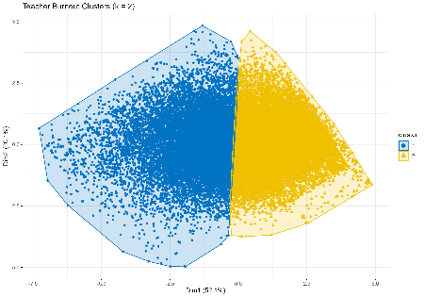
Figure 3: PCA projection of teacher profiles identified using K-Means clustering.
The first two principal components explain 52.1% and 20.1% of the variance, respectively. Principal Component Analysis (PCA) was used to visually assess the clustering structure. The PCA projection (Fig. 3) shows distinguishable grouping between the two clusters, with the first two components explaining approximately 72% of the total variance. While some overlap is present, the clusters occupy different regions in the reduced space, supporting the validity of the K-Means solution. The higher-risk profile shows a broader spread, whereas the lower-risk profile forms a more compact distribution.

CONCLUSION
This study demonstrates that unsupervised machine learning can identify meaningful latent profiles within large-scale educational datasets without relying on predefined burnout labels. Using K-Means clustering on TALIS 2018 data, two distinct profiles were identified, representing higher-risk and lower-risk burnout-related patterns based on proxy indicators such as workload stress, wellbeing, and job satisfaction. These profiles do not represent direct clinical measures of burnout but inferred risk patterns derived from observed data.
The findings indicate that teacher stress and wellbeing do not manifest uniformly but instead form structured, data-driven patterns influenced by institutional and behavioral factors. This provides a foundation for more scalable and context-sensitive approaches to understanding burnout across educational systems
Future Work: Building on these findings, future research will transition from exploratory analysis to predictive modeling. The identified cluster labels will be used as target variables to train supervised machine learning models, including Random Forests and Neural Networks. These models will be integrated with explainability techniques (e.g., SHAP) to enable early and interpretable prediction of burnout risk based on demographic and institutional indicators. This approach aims to support the development of scalable, cross-cultural early-warning systems for educator wellbeing.

REFERENCES
[1] D. J. Madigan and L. E. Kim, “Does teacher burnout affect students? A systematic review of its association with academic achievement and student-reported outcomes,” International Journal of Educational Research, vol. 105, p. 101714, 2021. https://doi.org/10.1016/j.ijer.2020.101714
[2] A. Pérez-Luño, M. Díez-Piñol, and S. L. Dolan, “Exploring high vs. low burnout amongst public sector educators: COVID-19 antecedents and profiles,” International Journal of Environmental Research and Public Health, vol. 19, no. 2, p. 780, 2022. https://doi.org/10.3390/ijerph19020780
[3] E. I. Shavers, H. K. Donnelly, K. A. S. Howard, and V. S. H. Solberg, “Predictors of teacher burnout during the COVID-19 pandemic using machine learning,” Scholarly Journal of Psychology and Behavioral Sciences, vol. 6, no. 3, pp. 707–712, 2022. https://doi.org/10.32474/SJPBS.2022.06.000238
[4] M. Xie, S. Huang, L. Ke, X. Wang, and Y. Wang, “The development of teacher burnout and the effects of resource factors: A latent transition perspective,” International Journal of Environmental Research and Public Health, vol. 19, no. 5, p. 2725, 2022. https://doi.org/10.3390/ijerph19052725
[5] S. An and S. Tao, “English as a foreign language teachers’ burnout: The predictive power of self-efficacy and well-being,” Acta Psychologica, vol. 245, p. 104226, 2024. https://doi.org/10.1016/j.actpsy.2024.104226
[6] D. J. Madigan, L. E. Kim, H. L. Glandorf, and O. Kavanagh, “Teacher burnout and physical health: A systematic review,” International Journal of Educational Research, vol. 119, p. 102173, 2023. https://doi.org/10.1016/j.ijer.2023.102173
[7] Y. Wang, “Exploring the impact of workload, organizational support, and work engagement on teachers’ psychological wellbeing: A structural equation modeling approach,” Frontiers in Psychology, vol. 14, p. 1345740, 2024. https://doi.org/10.3389/fpsyg.2023.1345740
[8] J. Kim, P. Youngs, and K. A. Frank, “Burnout contagion: Is it due to early career teachers’ social networks or organizational exposure?” Teaching and Teacher Education, vol. 66, pp. 250–260, 2017. https://doi.org/10.1016/j.tate.2017.04.017
[9] M. M. Sohail, A. Baghdady, J. Choi, H. V. Huynh, K. Whetten, and R. J. Proeschold-Bell, “Factors influencing teacher wellbeing and burnout in schools: A scoping review,” Work, vol. 76, no. 4, pp. 1317–1331, 2023. https://doi.org/10.3233/WOR-220234
[10] I. Pagán-Garbín, I. Méndez, and J. P. Martínez-Ramón, “Exploration of stress, burnout, and technostress levels in teachers: Prediction of resilience using an artificial neural network,” Teaching and Teacher Education, vol. 148, p. 104717, 2024. https://doi.org/10.1016/j.tate.2024.104717
[11] B. Agyapong, R. da Luz Dias, Y. Wei, and V. I. O. Agyapong, “Burnout among elementary and high school teachers in three Canadian provinces: Prevalence and predictors,” Frontiers in Public Health, vol. 12, p. 1396461, 2024. https://doi.org/10.3389/fpubh.2024.1396461
[12] OECD, TALIS 2018 Results (Volume I): Teachers and School Leaders as Lifelong Learners. Paris: OECD Publishing, 2019. https://doi.org/10.1787/1d0bc92a-en
[13] L. D. Prasojo et al., “Teachers’ burnout: A SEM analysis in an Asian context,” Heliyon, vol. 6, no. 12, p. e03144, 2020. https://doi.org/10.1016/j.heliyon.2019.e03144

