Comprehensive Analysis of Global AI Tool Usage: trends, insights, and predictive perspectives

Dr. Mariam Alshammari
Foundations Program Unit
Gulf University for Science and Technology
Mubarak Al-Abdullah Area, Kuwait
alshammari.m@gust.edu.kw

Dr. Khaled Almustafa
Engineering Department
Gulf University for Science and Technology
Mubarak Al-Abdullah Area, Kuwait
almustafa.k@gust.edu.kw

Dr. Khuloud Alkhateeb
Computer Science Department
Gulf University for Science and Technology
Mubarak Al-Abdullah Area, Kuwait
khateeb.k@gust.edu.kw

Dr. Juliano Katrib
Engineering Department
Gulf University for Science and Technology
Mubarak Al-Abdullah Area, Kuwait
katrib.j@gust.edu.kw

Fatema Alalawi
Student Research Assistant
Gulf University for Science and Technology
Mubarak Al-Abdullah Area, Kuwait
GUST0025736@gust.edu.kw

https://doi.org/10.63962/LJVX2451

Abstract — The rapid proliferation of artificial intelligence (AI) tools across industries has increased interest in understanding global adoption patterns. However, existing research often focuses on specific tools, sectors, or regions, leaving a gap in large-scale empirical analyses. This study provides a data-driven examination of AI tool adoption using a dataset of 500 aggregated usage records representing millions of interactions across regions, industries, user types, and AI categories. Loosely guided by the Technology Acceptance Model, Diffusion of Innovations, and the Resource-Based View, the analysis employs descriptive statistics, clustering, correlation analysis, and time-series forecasting. Results reveal significant variability in tool usage, strong engagement with generative and text-to-image tools, weak correlations between contextual factors and usage levels, and identifiable seasonal patterns in AI adoption.
Keywords — AI adoption, global usage analysis, generative AI, seasonal patterns, regional AI trends

INTRODUCTION
Recent years have witnessed exponential growth in the deployment of artificial intelligence (AI) tools across diverse sectors and regions worldwide. Despite this proliferation, research on AI tool adoption has often been fragmented, limited to regional case studies, sector-specific accounts, or isolated technologies leaving a critical gap in our understanding of global, cross-sectoral usage patterns and their driving forces. Theoretical literature in technology adoption and innovation diffusion [18] suggests that factors such as geographic context, industrial sector, and user typology play pivotal roles in technology uptake. However, it remains empirically unclear whether these classical determinants hold in the rapidly evolving domain of AI, where tools are both highly modular and adaptable. Existing

studies have rarely, if ever, operationalized a multi-dimensional, comparative lens on real-world AI tool usage
at scale. It is important to note that several studies do indeed examine the capabilities of individual tools. For example, [6] delve into BERT's architecture and performance in NLP tasks, while Ramesh et al. [17] describe the generative capacities of DALL·E. While organizations such as UNESCO [22] and OECD [14] have expressed the importance and urgency of equity in AI and global accessibility, there is a lack of data-driven studies that show how different regions and industries are actually engaging with AI tools [13].

THEORETICAL FRAMEWORK
This study explains global AI tool usage through a multilevel framework that connects theory, measurement, and methods while keeping people at the center of the inquiry. The empirical analysis in this study is based on a structured dataset of AI tool usage compiled from the publicly available Global AI Tool Usage Dataset hosted on Kaggle. The dataset contains 500 individual usage records from 2023, each representing aggregated usage observations for a specific AI tool across contextual dimensions including region, industry sector, user type, category, and over time. Although the dataset consists of 500 records, each record represents aggregated counts of tool interactions rather than individual user sessions. As a result, aggregated usage values can reach into the millions when totals are computed across regions, industries, and user groups. This aggregation explains how a dataset containing 500 rows can produce cumulative usage counts exceeding several million interactions across tools and categories.
To investigate AI tool adoption patterns across contextual dimensions, this study employs a multi-stage analytical framework combining descriptive statistics, clustering techniques, correlation analysis, and predictive modeling. The goal is to understand why different tools are adopted across regions, industries, and user groups, and to do so with a structure that is testable using the variables available in the dataset.
TABLE I: ANALYSIS VARIABLES
Variable | Type | Definition
Tool Name | Categorical | AI system being analyzed (e.g., BERT, ChatGPT)
Category | Categorical | Functional classification of the AI tool (NLP, Generative AI, Text-to-Image)
Region | Categorical | Geographic region where usage was recorded
Industry | Categorical | Sector in which the tool is applied
User Type | Categorical | Type of user: enterprise, individual, or SMB
Month | Temporal | Month in which usage occurred
Usage Count | Numerical | Aggregated number of recorded interactions with the tool

While the dataset captures usage patterns across several major regions, industries, and tool categories, it should be interpreted as an exploratory empirical dataset rather than a complete representation of global AI activity. The purpose of the dataset is to identify structural patterns of AI tool usage across contextual dimensions, rather than to measure precise worldwide adoption levels. This dataset is an appropriate choice as it covers multiple fields and regions without bias, allowing for a more holistic representation of AI usage and potential trend indicators.
The framework integrates three lenses that operate at different levels. At the micro level, the Technology Acceptance Model explains how perceived usefulness and perceived ease of use shape individual decisions [5]. At the meso level, the Resource Based View explains how organizational capabilities and complementary assets condition adoption and value creation (Cuthbertson & Furseth, 2022). At the macro level, Diffusion of Innovations explains how technologies spread across populations over time and space [18]. Because the dataset does not include direct perceptual or firm-level measures, theoretical constructs are approximated through observable usage indicators. Within TAM, perceived usefulness is operationalized through the alignment between Category and Industry, reflecting task to technology fit, while perceived ease of use and accessibility are proxied by tool availability characteristics and higher usage among Individuals and SMBs. Within RBV, organizational resources and capabilities are approximated through the User Type variable (Enterprise, SMB, Individual), which reflects differing levels of technical and financial capacity to adopt AI tools. Within DOI, diffusion context and adoption dynamics are represented by Region and Month, while Usage Count reflects the observable intensity of adoption across these environments. These mappings allow the empirical variables to serve as proxy indicators for the theoretical mechanisms guiding AI tool adoption.
The dataset used in this study records tool usage by tool name, category, user type, industry, region, and month. However, it does not contain direct measures of individual beliefs or firm resources. Perceived ease of use and access are assessed by whether a tool is open source or closed, by whether licensing permits local usage without proprietary subscriptions when such information is available, and by whether tools are known to have broad localization or simple interfaces. Perceived usefulness is measured by category to task fit, which is encoded as interactions between tool categories and industries. Examples include Text-to-Image with Education because of content creation workflows, and Natural Language Processing with Healthcare and Finance because of document heavy tasks.

Hypotheses
From these mechanisms, the study derives three hypotheses that can be evaluated within the empirical strategy. Hypothesis 1 states that open-source tools are associated with higher usage among individuals and SMBs relative to purchased tools after controlling for other factors. The expectation is that lower access barriers and greater modifiability support broader participation. Hypothesis 2 sets competing expectations for regional effects. Classical diffusion suggests that region remains a strong predictor due to social and institutional differences. Hypothesis 3 states that usage exhibits seasonality that aligns with academic and organizational cycles, which implies predictable monthly patterns that should be recoverable by models with seasonal components.
- Limitations
Because the dataset aggregates data from multiple secondary sources, it should be interpreted as indicative of usage trends rather than fully representative of global AI adoption. Boundary conditions are explicit. The study does not observe individual perceptions; therefore, TAM constructs were evaluated through proxies rather than survey measures (Wang et al., 2021). The study does not observe firm level resources; therefore, RBV is approximated by user type and by tool affordances that lower integration costs. The study does not reconstruct social network ties. Because the study doesn’t track individual social connections, it looks at overall adoption trends to infer how usage spreads, rather than following the exact paths of influence between specific users or firms. These limits do not invalidate the framework, but they require careful interpretation where findings are described as consistent with theoretical expectations rather than definitive tests of latent beliefs (Norris, 2021).
This study seeks to address the gaps in literature by providing, to our knowledge, the first integrated, global, and data-driven analysis of AI tool adoption across key regions, industries, user types, and technology categories. Our approach combines advanced clustering and correlation analysis with state-of-the-art time series forecasting to illuminate not only current adoption landscapes but also future trends and uncertainties. We examine whether the assumed drivers of AI adoption, such as region or sector, meaningfully predict usage levels in practice. Our findings challenge common understanding by revealing surprisingly weak relationships between these variables and actual tool uptake, thereby calling for a fundamental reexamination of prevailing theoretical models in the context of modern AI diffusion.

ANALYSIS AND RESULTS
This section presents a comprehensive, data-driven exploration of global AI tool usage, offering both retrospective insights and forward-looking projections. Through eight interconnected analyses, it investigates how AI tools are adopted, distributed, and utilized across different dimensions ranging from regional and industry specific trends to user behaviors and category preferences. A comparative and ranking analysis identifies the leading tools and categories in terms of performance and popularity [23]. This is complemented by behavioral and category level insights, which will show how well different AI applications perform under varying conditions [7]. The analysis then progresses to segmented clustering, uncovering hidden usage patterns and correlations that group tools and users with similar behavior profiles. Finally, a suite of trend and predictive models will offer projections and strategic foresight into the future of AI tool engagement across regions, industries, and user types. Together, these layers of analysis provide a rich, multidimensional view of the evolving AI landscape, supporting informed decisions for stakeholders, researchers, and technology providers alike.
- Descriptive Analysis
The first stage involved computing summary statistics to understand the overall distribution of AI tool usage. The average (mean) usage count per AI tool is approximately 19,739, suggesting that on average, AI tools enjoy a moderate to high level of engagement globally [20]. However, the relatively high standard deviation of 8,834 indicates considerable dispersion around the mean, pointing to substantial variability in tool popularity [3]. Some AI tools are adopted at a significantly higher rate than others, likely reflecting differences in functionality, accessibility, and industry-specific demand. Additionally, the minimum recorded usage count is 5,102, while the maximum usage reaches 34,910, further emphasizing the presence of both niche and highly dominant tools. The median usage count (50th percentile) stands at 19,208.5, closely aligning with the mean, suggesting a relatively balanced distribution without extreme skewness. However, the spread between the 25th percentile (11,287) and the 75th percentile (27,040.5) confirms a wide interquartile range, indicating that while many tools fall within a mid-usage band, a significant number either greatly outperform or underperform relative to the average. These statistics reveal a significant variability in overall AI tool usage and utilization across industries, regions, and user types.
- Analysis of User Type Distribution
The user type distribution across major AI tools provides valuable insight into how different user segments (enterprise, individual, and small and medium businesses (SMBs) engage with specific technologies. The data reveals distinct usage patterns that reflect the functional strengths of each tool and the differing needs of user categories. This distribution suggests that BERT’s text processing capabilities are particularly accessible and useful for independent developers and smaller organizations, likely due to its broad open source availability and utility in various natural language processing tasks [6]. This supports our first hypothesis linking open-source availability to higher individual usage. ChatGPT, in contrast, has its largest user base in the enterprise segment, with 941,314 interactions, which indicates strong interest in conversational AI and customer service automation among larger organizations [15]. DALL·E, a text-to-image generative tool, shows a balanced distribution among the different user types. Stable Diffusion also displays a relatively even spread, with the highest use among SMBs (821,915), followed by individuals (780,618), and enterprises (660,328). As hypothesized, the open and customizable nature of Stable Diffusion likely contributes to its popularity among smaller businesses and independent users seeking affordable and flexible creative AI solutions.

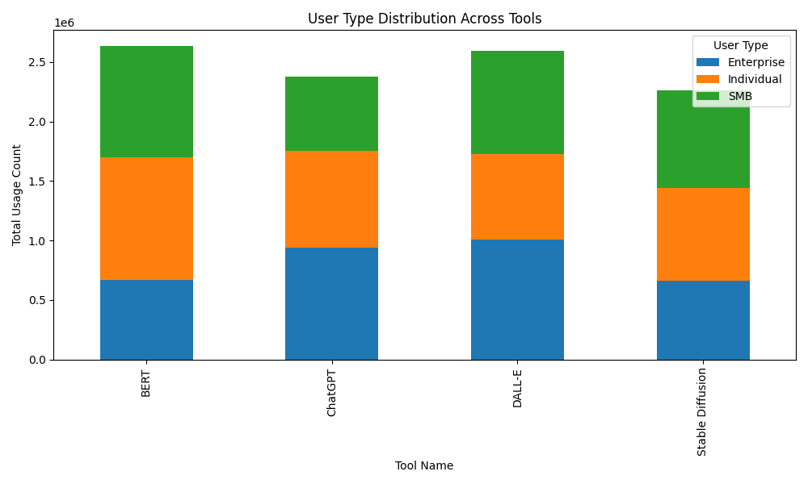
Fig. 1. User type distribution

Analysis of Top Tools by Region
To address our second hypothesis, we looked at specific trends in each region. The data suggests that while all four tools have global presence, regional preferences are shaped by local contexts [12]. North America and Europe lean toward visual content creation, while Asia balances between generative and analytical tools. Africa and South America exhibit strong engagement across categories, with notable peaks in ChatGPT and BERT usage, respectively. These patterns provide useful indicators for regional strategy alignment, localization of AI solutions, and targeted investment in AI infrastructure. In Asia, Stable Diffusion holds the highest usage (665,257), followed by BERT (603,063). This reflects a strong engagement with both visual generation and deep language models, likely driven by the region’s active developer and research communities [6] [12]. In Europe, DALL·E is the most used tool (573,752), showcasing a strong preference for creative AI applications. In North America, DALL·E again leads with 619,838 uses, reinforcing the region’s demand for content generation and design support [17]. South America presents a unique trend, with BERT topping the list (633,176). This suggests an academic or developer-driven focus on language modeling.

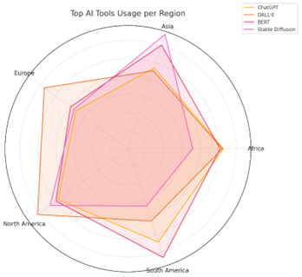
Fig. 2. Top tools per region

Analysis of Tool Usage by Industry
In the Education sector, Stable Diffusion leads with 622,658 recorded uses, followed by DALL·E (560,315) and BERT (515,607). This suggests that image generation and natural language understanding tools are widely used for educational content creation, e-learning applications, and classroom support materials. ChatGPT, while still significantly used (454,022), ranks fourth, possibly indicating that conversational AI is more supplementary than central in educational workflows [15]. In Entertainment, ChatGPT is the most used tool with 623,475 interactions, underscoring the demand for conversational AI in interactive content, virtual assistants, and audience engagement (ibid, 2023). BERT follows with 575,732 uses, reflecting its role in language-driven content analysis and recommendation engines. DALL·E and Stable Diffusion show lower, but still substantial, usage (473,143 and 394,805 respectively), pointing to strong but slightly less dominant roles in creative image generation. The Finance sector shows a clear preference for DALL·E (635,133) and BERT (592,694), indicating a heavy reliance on data representation and language modeling for document analysis, compliance automation, and report generation.
ChatGPT trails at 380,785, with Stable Diffusion having the lowest usage in this sector (338,279), likely due to the relatively limited use of visual generation in finance-specific applications. In Healthcare, BERT takes the lead with 530,659 uses, followed by DALL·E (469,364), ChatGPT (447,263), and Stable Diffusion (431,343). The prominence of BERT aligns with its effectiveness in processing medical literature, clinical notes, and patient data.

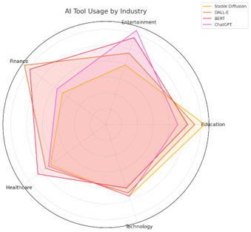
Fig. 3. Tool usage by industry
- Analysis of Monthly Trends in AI Tool Usage
The monthly usage data was used to test the third hypothesis, and the pattern reveals distinct fluctuations in AI tool adoption throughout the calendar year, suggesting both cyclical engagement and seasonal trends. December records the highest usage count at 1,038,744, indicating a significant spike in activity, potentially due to end-of-year reporting, academic deadlines, or increased experimentation during holiday downtime [1]. This peak is followed by high usage in February (947,814), March (934,442), and July (931,327), suggesting consistent engagement during the early and mid-year periods. Conversely, May (570,580) and October (591,812) show the lowest activity, marking them as periods of reduced usage. These dips could correspond to academic transitions, mid-year breaks, or organizational cycles where AI tool engagement temporarily slows down [16]. The moderate decline during August (700,688) aligns with global vacation periods, while the rebound in September (818,641) supports the idea of a renewed focus in early fall [8]. These data show that usage does exhibit seasonality and is influenced by seasonal patterns.
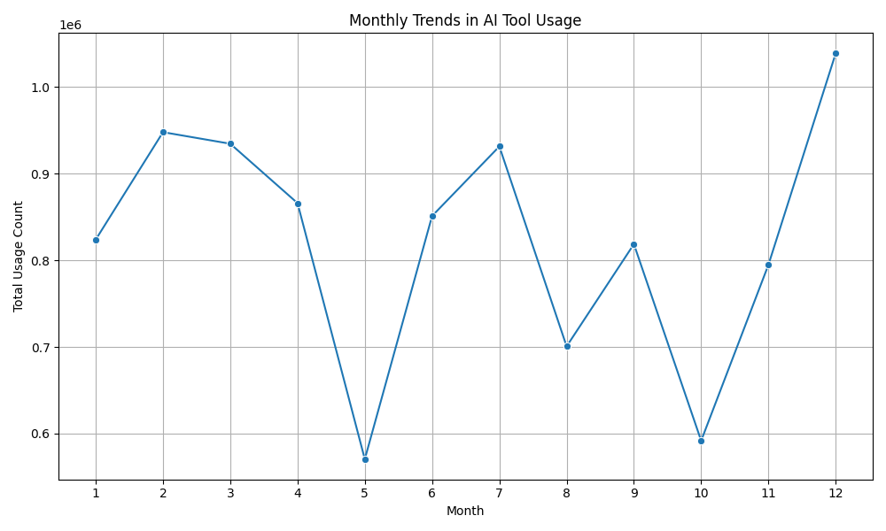
Fig. 4. Monthly trends

Analysis of Tool Evaluation Over the Year
To further explore hypothesis 3’s assumptions, specific spikes were noted. For instance, BERT shows a significant spike in usage in March (381,727), nearly doubling its usage compared to most other months. This could reflect its role in language, heavy tasks such as academic, legal, or financial reporting during Q1. Additionally, all AI models see a rise in September, which further supports the idea that academia heavily impacts usage – from both student and faculty usage. [4]. Following this peak, usage declines but remains relatively stable, with another moderate rise in December (270,539), likely aligning with end-of-year analysis and document-heavy tasks. ChatGPT maintains strong performance throughout the year, peaking in February (278,502) and again in July (258,616). Its consistency suggests it is widely used for interactive and conversational tasks regardless of season, though dips in October (107,133) and May (114,715) suggest periods of lower demand, possibly linked to exam cycles or organizational slowdowns. DALL·E, a generative visual model, sees a clear usage rise mid- year, with its highest values in June (271,111) and April (269,692), suggesting a preference for creative applications during spring and summer periods. This further supports the hypothesis of predictable seasonal patterns in AI tool usage.
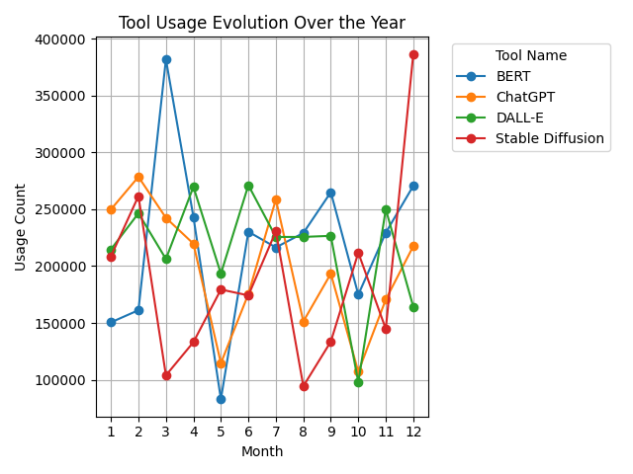
Fig. 5. Tool evaluation over year

Analysis of Tool Preferences by User Type
The distribution of AI tool usage across user types, Enterprise, Individual, and SMB (Small and Medium Businesses), reveals clear distinctions in how different segments engage with AI technologies based on their needs, scale, and resources. Enterprises show the highest usage of DALL·E (1,007,777). This suggests a strong preference for generative visual and conversational tools, likely used for branding, automation, and customer applications [9]. Individual users exhibit the highest overall usage of BERT (1,030,877), pointing to widespread adoption of language models in educational, research, and personal projects [15]. SMBs demonstrate balanced engagement across all tools, with particularly strong usage of DALL·E (865,393) and Stable Diffusion (821,915). These tools likely appeal to SMBs for marketing, design, and low-cost content creation. This analysis further supports our hypothesis that open-source tools are associated with higher usage among individuals and SMBs relative to purchased tools.

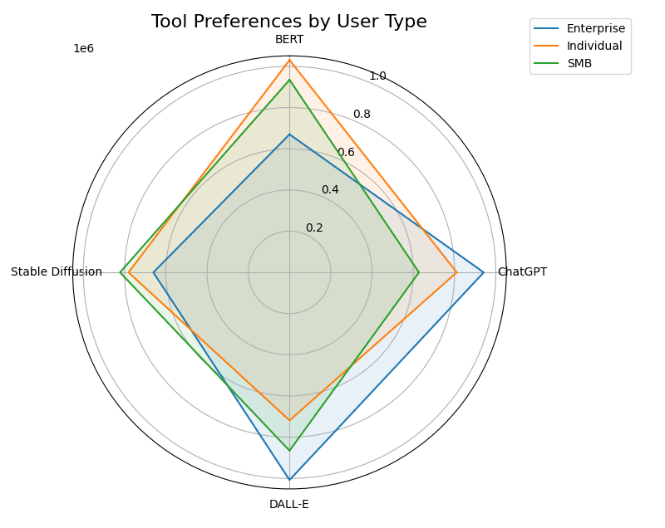
Fig. 6. Tool preference by user type

H. Analysis of Category Preferences by User Type
While further exploring hypothesis one, the distribution of AI tool usage across categories, Generative AI, NLP (Natural Language Processing), and Text- to-Image, for different user types reveals distinct usage priorities aligned with organizational goals, resource availability, and creative needs [12] [20]. Enterprises show almost equal engagement with Generative AI (1,171,966) and Text-to-Image tools (1,164,078), highlighting a strong emphasis on scalable content generation and visual communication. SMBs (Small and Medium Businesses) prioritize Text-to-Image tools (1,338,483). Generative AI tools (1,092,833) are also widely used, reflecting SMBs' need for cost-effective, multifunctional AI solutions. NLP tools (818,012) see comparatively lower use, potentially due to limited in-house resources or lower demand for complex language-based automation [13]. Cost here plays a role in selection, with free open-source tools being favored.

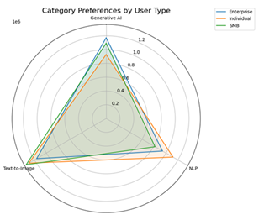
Fig. 7. Category preference by user type

- Analysis of Tool Usage by Category
BERT, which is an open-source tool, demonstrates consistently high usage across all three categories, Generative AI, NLP, and Text-to-Image, In the Generative AI category, BERT leads with a usage count of 889,981, followed closely by DALL·E at 859,933 and Stable Diffusion at 772,946. ChatGPT, while widely recognized, ranks fourth in this group with 671,099 uses. This suggests that despite ChatGPT’s conversational strengths, tools like BERT and DALL·E may offer more value in generative applications involving structured outputs or visual generation. Within the NLP category, DALL·E surprisingly leads with 851,861 uses, possibly due to multi-category overlap where it supports tasks involving text and images. ChatGPT (662,613) and BERT (629,197) also show strong presence, consistent with their core capabilities in language modeling and comprehension. In the Text-to-Image category, BERT has the highest usage overall with 1,116,439, a surprising result that may indicate repurposing or classification overlap.
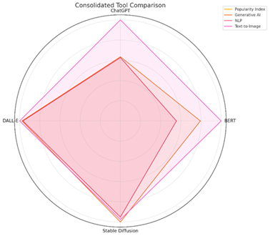
Fig. 8. Top tools by category

SEGMENTED ANALYSIS: TOOL CLUSTERING AND BEHAVIOURAL INSIGHTS

Segmented analysis enables a more detailed understanding of AI tool usage by uncovering behavioral patterns across different regions, industries, and categories [11]. This section presents two core methods: clustering analysis to group tools by similar usage profiles, and correlation analysis to examine how factors like region, industry, and category influence tool adoption.

A. Clustering Analysis: Grouping Tools by Usage Behavior
A K-means clustering algorithm was applied to group tools based on their usage distribution across regions, industries, and AI categories. The goal was to identify natural clusters that represent distinct behavioral and adoption trends. The algorithm grouped tools into three clusters (see table ii):
- Cluster 0: ChatGPT
- Cluster 1: DALL·E and Stable Diffusion
- Cluster 2: BERT
ChatGPT demonstrates balanced usage across all examined regions, with particularly high activity in South America and Asia. It is widely adopted in the finance sector and is used extensively across all major AI categories, Generative AI, NLP, and Text-to-Image, highlighting its adaptability and broad functionality. Cluster 1 represents tools designed for high-impact creative AI applications. These tools, DALL·E and Stable Diffusion, show nearly identical patterns, being heavily favored for visual tasks in the Text-to-Image and Generative AI categories. They are most popular in Asia and North America and are primarily used in the Finance and Healthcare sectors. Lastly, BERT is traditionally an NLP-focused tool, however, it shows strong usage in Text-to-Image applications in this dataset. It is most heavily used in South America and shows high adoption in Finance and Entertainment. Its behavior pattern is unique, setting it apart from the other tools.
TABLE II: CLUSTER-BASED INSIGHTS
Cluste | Tool Name | Strongest Region | Top Industries | Dominant Categories
2 | BERT | South America | Finance, Entertainment | Text-to-Image
0 | ChatGPT | South America, Asia | Finance | Generative AI, NLP,  Text-to-Image
1 | DALL·E | North America, Asia | Finance, Healthcare | Text-to-Image,  Generative AI
1 | Stable Diffusion | North America, Asia | Finance, Healthcare | Text-to-Image,  Generative AI

A. Correlation Analysis: Region, Industry, Category & Usage
To complement the segmented clustering, a correlation matrix analysis was conducted to examine the relationships between region, industry, category, and usage count. The relationship between Region and Usage Count shows a very slight positive correlation of 0.03, indicating that geographic location has minimal impact on overall AI tool usage in this dataset. Category shows the highest correlation with Usage Count at 0.035, suggesting that the type of AI tool, such as NLP or Text-to-Image, has a slightly greater, though still marginal, influence on usage levels. In contrast, Industry shows an almost negligible correlation of 0.007 with usage, implying that the sector in which the tool is applied does not significantly affect its adoption. Additionally, the few negative correlations observed, such as between Category and Industry, analysis reveals that no single factor, be it region, industry, or category, shows a strong correlation with usage count, indicating that AI tool adoption is broadly distributed and likely shaped by a combination of variables rather than any one dominant influence.

TABLE III: CORRELATION MATRIX
Variable | Region | Industry | Category | Usage Count
Region | 1.000000 | 0.008855 | -0.000712 | 0.029910
Industry | 0.008855 | 1.000000 | -0.024872 | 0.006913
Category | -0.000712 | -0.024872 | 1.000000 | 0.034758
Usage Count | 0.029910 | 0.006913 | 0.034758 | 1.000000

- TREND AND PREDICTIVE ANALYSIS
This section focuses on uncovering future trends and potential developments in global AI tool usage through predictive analytics. By leveraging advanced modeling techniques, we analyze historical usage data to project future demand and seasonality patterns [10] [19]. The three techniques used were as follow:
- ARIMA: a Time-Series Regression Model that accounts for autoregressive trends and moving averages [2] [19]
- Exponential Smoothing: a method that smooths the trend over time by giving more weight to recent data.
- Prophet: a flexible additive model designed to handle seasonality and holidays [21]. It also provides confidence intervals for its predictions [21].
This analysis helps to identify emerging adoption patterns and highlights areas, particularly underrepresented regions or industries, where AI tool usage may experience significant growth. Together, these predictive approaches support informed decision-making, targeted development, and resource allocation in the evolving AI landscape.

Time Series Forecasting
To project future usage trends, we applied three well-established forecasting models: Exponential Smoothing, ARIMA, and Prophet. These models use historical monthly usage data to estimate future counts and identify underlying seasonal patterns or momentum. Exponential smoothing captured short-term trends, ARIMA modeled autocorrelation and time dependence, and Prophet decomposed the series into trend and seasonal components. Forecast accuracy was evaluated using mean absolute error (MAE) and root mean squared error (RMSE) Exponential Smoothing (see Glossary) anticipates a slow and steady decline, potentially reflecting seasonal drops or market saturation. ARIMA projects a more optimistic scenario, suggesting continued interest in AI tool usage, albeit with mild decline over time. Prophet offers a conservative estimate with relatively wide confidence bounds, indicating moderate uncertainty in future adoption patterns. Prophet, on the other hand, offers a conservative estimate with relatively wide confidence bounds, indicating moderate uncertainty in future adoption patterns. Collectively, these models highlight both the resilience and the volatility in AI tool adoption trends, underlining the importance of continued monitoring and adaptive planning as the landscape evolves. These findings therefore support Hypothesis 3, indicating that AI tool adoption follows predictable seasonal rhythms which allow for forecasting of use.
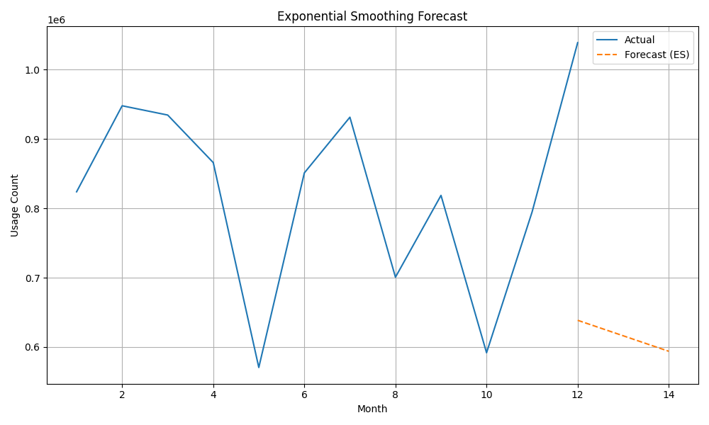

Fig. 9. Exponential Smoothing
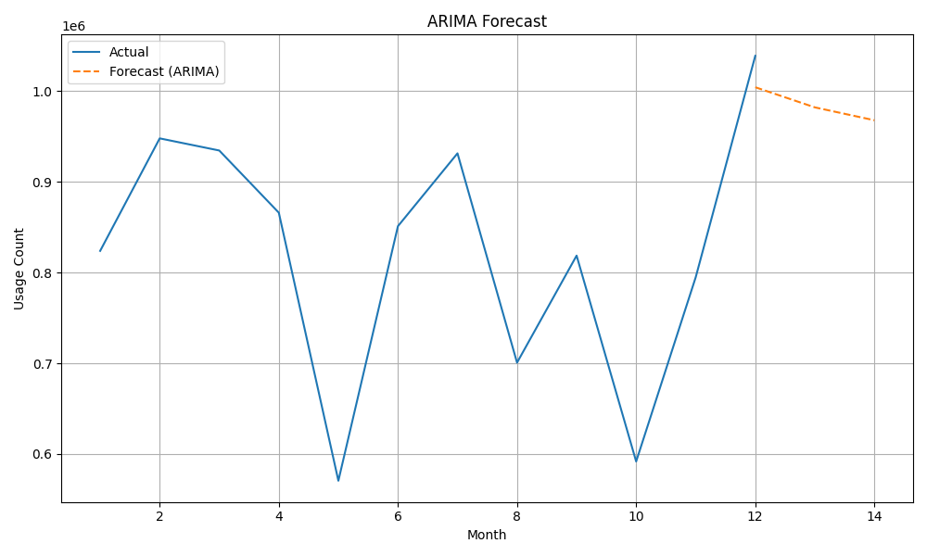
Fig. 10. ARIMA Forecasting
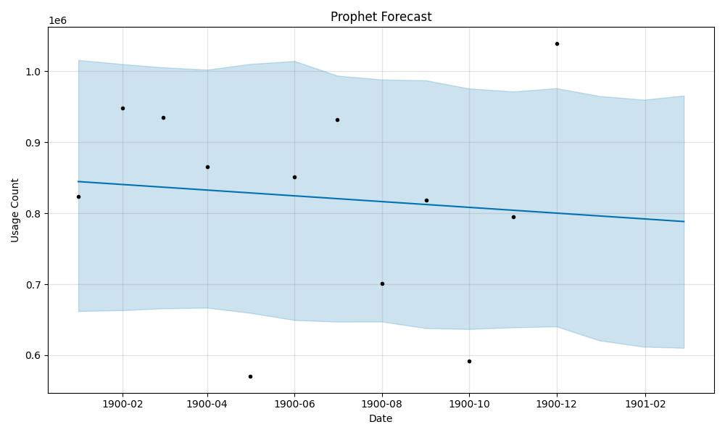
Fig. 11. Prophet Forecasting

DISCUSSION
This study embarked on a comprehensive analysis of global AI tool usage, aiming to bridge critical gaps in the existing literature by providing a multidimensional, data-driven perspective on adoption patterns across regions, industries, user types, and technology categories. The analysis focused on testing whether: 1) geographic region significantly predicts usage levels, 2) industry sector influences adoption patterns, and 3) tool category contributes to variation in usage counts.
Our findings, while constrained by data limitations as discussed previously, offer several insights that challenge conventional wisdom and contribute to the evolving discourse on AI diffusion and acceptance. Our descriptive analyses revealed significant variability in AI tool adoption, with certain tools like BERT, DALL·E, and ChatGPT demonstrating widespread engagement. Notably, text-to-image tools emerged as a dominant category, particularly among Small and Medium Businesses (SMBs) and individual users, underscoring a strong market demand for visual content generation. Geographically, Asia and North America exhibited high overall usage, while specific regional preferences for tools like BERT in South America and DALL·E in Europe highlighted the influence of local contexts and priorities. Perhaps the most striking and counter-intuitive finding was the surprisingly weak linear correlation between traditional drivers such as region, industry, and overall AI tool usage. This suggests that the diffusion of AI tools may not adhere strictly to established patterns observed in previous technological adoptions, implying a more pervasive and less geographically or sector-bound integration
Furthermore, our findings also show that AI tool usage is not uniform across the year; rather, it follows identifiable seasonal and functional peaks. Understanding these trends is crucial for resource planning, platform optimization, and designing time sensitive outreach or feature rollouts aligned with periods of high user engagement.
Correlation analysis and regression models were used to assess these relationships. The results indicate that individual contextual variables exhibit weak statistical relationships with overall usage, suggesting that AI adoption patterns are shaped by multi-factor dynamics rather than single structural predictors.

Implications for Education and Artificial Intelligence
This study carries significant implications for both the education sector and the broader field of artificial intelligence development and policy. For Education, the high usage of AI tools, particularly text-to-image and NLP, underscores their growing integration into learning and teaching processes. Educators and curriculum designers must recognize the pervasive nature of these tools and adapt pedagogical strategies to leverage their potential effectively. The observed seasonal usage patterns suggest opportunities for targeted training and resource allocation during peak periods. Furthermore, the strong engagement of SMBs and individuals in education highlights the need for accessible, cost-effective AI solutions that cater to diverse educational settings, from small institutions to independent learners. The findings also imply that educational policies around AI adoption should focus less on broad regional or industrial mandates and more on fostering an environment where the perceived usefulness and ease of use of specific AI tools can drive organic integration into educational practices.

CONCLUSION
This study provided a foundational, multi-dimensional analysis of global AI tool usage, offering insights into adoption patterns across various regions, industries, user types, and technology categories. Despite the inherent limitations of the dataset, our findings challenge the conventional understanding that AI tool diffusion is strongly predicted by traditional factors such as geographic location or industrial sector. Instead, the data suggests a more complex landscape where tool-specific utility, user accessibility, and emergent applications play a significant role in shaping adoption dynamics. The observed dominance of text-to-image tools, the surprising versatility of models like BERT across diverse categories, and the identifiable seasonal usage patterns collectively underscore the need for a more nuanced understanding of AI integration into daily practices. Our work contributes to the literature by highlighting the critical research gap in comprehensive, global, usage-based analyses of AI tools. By applying a multi-theoretical lens encompassing Diffusion of Innovation, Technology Acceptance Model, and the Resource- Based View, we have provided a preliminary framework for interpreting these complex adoption behaviors.

REFERENCES
- Bakhmetyeva, A. (2025). ChatGPT’s summer slump: How seasonality affects generative AI demand. LinkedIn / Similarweb traffic analysis.
- Box, G. E. P., Jenkins, G. M., Reinsel, G. C., & Ljung, G. M. (2016). Time series analysis: Forecasting and control (5th ed.). Wiley.
- Chen, L., Zhao, Q., & Wang, M. (2022). Measuring user engagement and performance variability across AI applications. International Journal of Human–Computer Interaction, 38(14), 1291–1305. https://doi.org/10.1080/10447318.2022.2024567
- Copyleaks. (2025, September 18). Study: 90 percent of students use AI for academic purposes [Press release]. Globe Newswire. https://www.globenewswire.com/news-release/2025/09/18/3152496/0/en/STUDY-90-Percent-of-Students-Use-AI-for-Academic-Purposes.html
- Davis, F. D. (1989). Perceived usefulness, perceived ease of use, and user acceptance of information technology. MIS Quarterly, 13(3), 319–340. https://doi.org/10.2307/249008
- Devlin, J., Chang, M. W., Lee, K., & Toutanova, K. (2019). BERT: Pre-training deep bidirectional transformers for language understanding. In Proceedings of NAACL-HLT, 4171–4186. https://doi.org/10.48550/arXiv.1810.04805
- Ghassemi, M., Oakden-Rayner, L., & Beam, A. L. (2022). The false hope of current approaches to explainable artificial intelligence in health care. The Lancet Digital Health, 4(11), e745–e750. https://doi.org/10.1016/S2589-7500(22)00168-2
- Golder, S. A., & Macy, M. W. (2011). Diurnal and seasonal mood vary with work, sleep, and daylength across diverse cultures. Science, 333(6051), 1878–1881. https://doi.org/10.1126/science.1202775
- Huang, Y., Patel, S., & Kim, J. (2023). Adoption patterns and use cases of generative AI: A focus on text-to-image systems. Journal of Creative AI Applications, 4(1), 22–35. https://doi.org/10.1016/j.jcai.2023.01.003
- Hyndman, R. J., & Athanasopoulos, G. (2018). Forecasting: Principles and practice (2nd ed.). OTexts. https://otexts.com/fpp2/
- Jain, A. K. (2010). Data clustering: 50 years beyond K-means. Pattern Recognition Letters, 31(8), 651–666. https://doi.org/10.1016/j.patrec.2009.09.011
- Khandelwal, A. (n.d.). AI tools usage [Data set]. Kaggle. https://www.kaggle.com/datasets/adityakhandelwal9601/ai-tools-usage
- Malik, O. R. (2025). The emerging AI “revolution tranquille” in America: Regional, industry, and firm-size dynamics of AI adoption. arXiv. https://doi.org/10.48550/arXiv.2505.14721
- OECD. (2023). AI in society: Policy considerations and implications. Organisation for Economic Co-operation and Development. https://www.oecd.org/going-digital/ai/
- OpenAI. (2023). ChatGPT: Optimizing language models for dialogue. https://openai.com/blog/chatgpt
- Prober, A. (2025). Which software forecasts seasonal shifts in AI search? Brandlight.ai.
- Ramesh, A., Pavlov, M., Goh, G., Gray, S., Voss, C., Radford, A., ... & Sutskever, I. (2022). Hierarchical text-conditional image generation with CLIP latents. https://doi.org/10.48550/arXiv.2204.06125
- Rogers, E. M. (2003). Diffusion of innovations (5th ed.). Free Press.
- Sharma, A., & Bansal, A. (2020). Forecasting trends in artificial intelligence using ARIMA and LSTM models. Journal of Data Science and Analytics, 1(3), 155–164. https://doi.org/10.1007/s41060-020-00200-x
- Smith, J. A., & Kumar, R. (2023). Global adoption trends of AI tools: A usage-based statistical analysis. Journal of Emerging Technologies and Society, 5(1), 45–60. https://doi.org/10.1177/26345161231111658
- Taylor, S. J., & Letham, B. (2018). Forecasting at scale. The American Statistician, 72(1), 37–45. https://doi.org/10.1080/00031305.2017.1380080
- UNESCO. (2021). AI and education: Guidance for policy-makers. United Nations Educational, Scientific and Cultural Organization. https://unesdoc.unesco.org/ark:/48223/pf0000376709
- Zhou, Y., Han, C., Wang, H., & Xu, Y. (2023). A comparative evaluation of AI-powered tools across multiple industries. Journal of Artificial Intelligence Research, 76, 349–372. https://doi.org/10.1613/jair.1.139

